**AUTOREM: AUTOLOGIN AND ERP REMINDER**

**A PROJECT REPORT**

***Submitted by***

**MUNEESH P (220701175)**

***in partial fulfilment for the course***

## OAI1903 - INTRODUCTION TO ROBOTIC PROCESS AUTOMATION

***for the degree of***

**BACHELOR OF ENGINEERING**

**in**

**COMPUTER SCIENCE AND ENGINEERING**

**RAJALAKSHMI ENGINEERING COLLEGE RAJALAKSHMI NAGAR THANDALAM CHENNAI – 602 105**

**NOVEMBER 2024**

**RAJALAKSHMI ENGINEERING COLLEGE**

**CHENNAI - 602105**

**BONAFIDE CERTIFICATE**

Certified that this project report **“AUTOREM: AUTOLOGIN AND ERP REMINDER”** is the bonafide work of **“MUNEESH P (220701175)”** who carried out the project work for the subject OAI1903-Introduction to Robotic Process Automation under my supervision.

**SIGNATURE**

**Mrs. G.M. Sasikala, M.E**

## SUPERVISOR

Assistant Professor

Department of Computer

Science and Engineering

Rajalakshmi Engineering College

Rajalakshmi Nagar

Thandalam

Chennai – 602105

Submitted to Project and Viva Voce Examination for the subject OAI1903-

Introduction to Robotic Process Automation held on ________

**Internal Examiner External Examiner**

# ABSTRACT

The Autorem: AutoLogin and ERP Reminder project is designed to streamline the process of managing assignment deadlines for students, addressing a common challenge of navigating complex ERP (Enterprise Resource Planning) systems. Academic ERP platforms often serve as repositories for critical information, such as assignment due dates, but the sheer volume of data and the need for frequent manual checks can lead to missed deadlines and added stress for students. Autorem simplifies this process by automating the retrieval of assignment-related information and providing timely notifications to ensure better task management.The core functionality of Autorem relies on Robotic Process Automation (RPA), which enables it to securely store user credentials and perform background login to the ERP system. Once logged in, the system identifies and extracts relevant assignment data, such as due dates, from the portal. This data is then organized into actionable insights and integrated with an email alert mechanism. Users receive reminders directly in their inboxes, ensuring they stay updated without the need to manually log into the portal repeatedly. Unlike traditional ERP usage, which can be time-consuming and prone to oversight, Autorem offers a lightweight and efficient solution tailored specifically for managing assignments. By focusing exclusively on academic tasks, it eliminates distractions such as fee payment updates or other non-critical notifications. The project also incorporates a user-friendly dashboard where students can view a consolidated summary of upcoming deadlines at a glance, further enhancing usability. Autorem is designed to operate in the background, reducing the manual effort required to track deadlines while ensuring data security and privacy.

# ACKNOWLEDGEMENT

Initially we thank the Almighty for being with us through every walk of our life and showering his blessings through the endeavour to put forth this report. Our sincere thanks to our Chairman **Thiru. S. Meganathan, B.E., F.I.E.,** our Vice Chairman **Mr. M. Abhay Shankar, B.E., M.S.,** and our respected Chairperson **Dr. (Mrs.) Thangam Meganathan, M.A., M.Phil., Ph.D.,** for providing us with the requisite infrastructure and sincere endeavouring in educating us in their premier institution.

Our sincere thanks to **Dr. S.N.Murugesan, M.E., Ph.D.,** our beloved Principal for his kind support and facilities provided to complete our work in time. We express our sincere thanks to **Dr. P.Kumar, M.E., Ph.D.,** Professor and Head of the Department of Computer Science and Engineering for his guidance and encouragement throughout the project work. We convey our sincere and deepest gratitude to our internal guide, **Dr.N.Durai Murugan, M.E., Ph.D.,** Associate Professor, Department of Computer Science and Engineering, Rajalakshmi Engineering College for their valuable guidance throughout the course of the project. We are very glad to thank our Project Coordinator, **Mr.B.Bhuvaneswaran, M.E.,** Assistant Professor (SG), and Supervisor **Mrs. G.M. Sasikala, M.E., Ph.D** Department of Computer Science and Engineering for his useful tips during our review to build our project.

**MUNEESH P (220701175)**

**TABLE OF CONTENTS**

**CHAPTER NO. TITLE PAGE NO.**

**ABSTRACT iii**

**LIST OF FIGURES vi**

**LIST OF ABBREVIATIONS vi**

1. **INTRODUCTION 1**
   1. GENERAL 1
   2. OBJECTIVE 1
   3. EXISTING SYSTEM 2

## 1.4 PROPOSED SYSTEM 2

1. **LITERATURE REVIEW 3**

2.1 GENERAL 3

1. **SYSTEM DESIGN 5**

3.1 GENERAL 5

3.1.1 SYSTEM FLOW DIAGRAM 6

3.1.2 ARCHITECTURE DIAGRAM 7

3.1.3 SEQUENCE DIAGRAM 8

1. **PROJECT DESCRIPTION 9**

4.1 METHODOLOGY 9

4.1.1 MODULES 11

1. **CONCLUSION 14**

5.1 GENERAL 14

**REFERENCES 16**

**APPENDICES**  26

**LIST OF FIGURES**

|  |  |  |
| --- | --- | --- |
| **FIGURE NO** | **FIGURE NAME** | **PAGE NO** |
| 3.1 | SYSTEM FLOW DIAGRAM | 10 |
| 3.2 | ARCHITECTURE DIAGRAM | 12 |
| 3.3 | SEQUENCE DIAGRAM | 14 |

**LIST OF ABBREVIATIONS**

|  |  |
| --- | --- |
| **ABBREVIATION** | **DEFINITION** |
| API | Application Programming Interface |
| CRM | Customer Relationship Management |
| ERP | Enterprise Resource Planning |
| OCR | Optical Character Recognition |
| IDE | Integrated Development Environment |
| UML | Unified Modeling Language |
| UI | User Interface |
| LMS | Learning Management System |

## CHAPTER 1

## INTRODUCTION

### 1.1 General

With the increasing reliance on digital platforms in academic institutions, students frequently interact with ERP (Enterprise Resource Planning) systems to access critical information such as assignment deadlines and course updates. However, manually checking these systems regularly to keep track of due dates is a time-consuming and error-prone process. Missing important deadlines can lead to academic setbacks, which emphasizes the need for an efficient solution.

This project, titled "Autorem: AutoLogin and ERP Reminder," leverages Robotic Process Automation (RPA) to address these challenges. Autorem automates the ERP login process, extracts assignment-related information, and provides timely reminders to students via email notifications. By eliminating the need for manual intervention, this tool not only saves time but also reduces the likelihood of missed deadlines, helping students better manage their academic responsibilities.

### 1.2 Objective

The primary objectives of this project are:

1. To automate the process of logging into ERP systems and retrieving assignment-related information using RPA.
2. To send timely email notifications to users about upcoming assignment deadlines, ensuring they remain well-informed.
3. To enhance productivity by minimizing the need for repetitive manual checks of ERP portals.
4. To develop a lightweight, scalable, and user-friendly solution that caters specifically to assignment management

### 1.3 Existing System

In academic institutions, managing assignment deadlines often relies on students manually logging into ERP (Enterprise Resource Planning) systems to check for updates. This existing system requires repetitive effort, as students need to frequently access the portal, navigate through multiple pages, and identify relevant information regarding assignment due dates. This process is time-consuming, especially for students juggling multiple courses and tasks. Furthermore, manual tracking increases the likelihood of missed deadlines, as it relies heavily on individual diligence and memory. There are no integrated reminder mechanisms within many ERP systems, leaving students prone to oversight and inefficiency in managing their academic schedules.

### 1.4. Proposed System

The proposed system, "Autorem: AutoLogin and ERP Reminder," introduces an automated solution leveraging Robotic Process Automation (RPA) to address the inefficiencies of the existing system. This system automates the login process to the ERP platform, extracts assignment-related information, and delivers timely reminders via email notifications. By eliminating manual intervention, Autorem ensures that students receive accurate and consistent updates about their assignments. Key features of the proposed system include secure storage of login credentials, efficient parsing of assignment data, and seamless email integration to notify students about due dates. Additionally, the system is designed to operate in the background with minimal resource consumption, providing a user-friendly experience. This automation reduces the risk of human error, saves time, and enhances productivity, enabling students to manage their academic responsibilities more effectively. By focusing exclusively on assignment deadlines, Autorem provides a targeted, practical, and scalable solution to improve academic task management.

## CHAPTER 2

## LITERATURE REVIEW

### 2.1 General

The automation of academic task management in educational institutions has become increasingly important as digital systems evolve and the volume of information grows. Traditional methods, which require students to manually check ERP (Enterprise Resource Planning) portals for assignment updates, are not only inefficient but also susceptible to human oversight. This often results in missed deadlines, reduced productivity, and increased stress among students. To address these issues, Robotic Process Automation (RPA) has emerged as a promising solution for automating repetitive and time-consuming processes.

RPA tools like UiPath have demonstrated their ability to improve efficiency across various domains by automating rule-based tasks such as data extraction, processing, and notifications. Studies have shown that RPA can reduce manual effort by up to 70% and improve accuracy in task management systems. These tools can interact with web-based platforms, extract relevant information, and trigger notifications or actions without human intervention. In the context of ERP systems, RPA has been successfully applied to automate tasks such as attendance tracking, exam scheduling, and assignment management, highlighting its potential to improve operational efficiency.

Several studies have focused on the implementation of RPA in educational settings, emphasizing its role in reducing repetitive tasks and minimizing errors. For example, RPA has been used to streamline processes like student admissions, grade compilation, and report generation, demonstrating substantial time savings and improved data accuracy. Research also highlights the scalability of RPA solutions, making them adaptable for various use cases, including assignment tracking and reminders.

Tools like UiPath are particularly effective for automating ERP interactions due to their advanced web automation capabilities and user-friendly design. UiPath’s ability to securely store credentials, interact with dynamic web elements, and integrate with email services makes it ideal for systems like "Autorem: AutoLogin and ERP Reminder." Despite its benefits, implementing RPA solutions comes with challenges, such as ensuring compatibility with evolving ERP interfaces and addressing data security concerns. Regular updates and robust error-handling mechanisms are essential to maintain system reliability.

The literature supports the integration of RPA technologies like UiPath for automating assignment reminders in academic settings. By leveraging these technologies, projects like Autorem can significantly enhance the efficiency of assignment tracking, reduce manual intervention, and ensure students are well-informed about their deadlines. This not only improves academic productivity but also fosters a more organized and stress-free learning environment.

## CHAPTER 3

## SYSTEM DESIGN

### 3.1 General

System design forms the foundation for developing robust and efficient solutions that meet specific functional and non-functional requirements. In the context of "Autorem: AutoLogin and ERP Reminder," the system design process involves carefully planning the architecture to ensure reliability, scalability, and ease of use. The high-level architecture incorporates components such as client-server communication, secure credential management, and data processing modules, all of which work seamlessly to automate ERP interactions and deliver timely reminders. Special emphasis is placed on creating a modular design that allows for easy debugging, updates, and integration with existing systems. The automation process relies on APIs and web scraping techniques to fetch data, while secure protocols are implemented to protect sensitive user credentials and ensure compliance with privacy standards. The system also includes error-handling mechanisms to deal with unexpected changes in the ERP interface, ensuring uninterrupted functionality.

At a granular level, the system's design is structured to achieve optimal performance and user satisfaction. RPA workflows are at the core of the implementation, handling tasks like logging into the ERP system, extracting assignment data, and formatting it for email alerts. The design supports horizontal scalability to accommodate an increasing number of users and assignments without compromising speed or accuracy. A user-friendly dashboard is planned to display consolidated assignment information in an intuitive format, enhancing accessibility. Data security is another critical aspect, with encryption methods used to store and transmit sensitive information securely. The system is built with future growth in mind, ensuring that it can adapt to new requirements or incorporate additional features, such as mobile notifications or integration with other academic tools. By combining simplicity with robustness, the system design ensures that Autorem delivers a reliable, scalable, and efficient solution for managing assignment deadlines.

#### 3.1.1 System Flow Diagram

#### 

Fig 3.1.1 System Flow Diagram

#### 3.1.2 Architecture Diagram

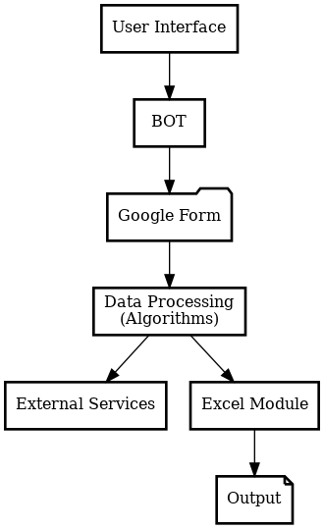

Fig 3.1.2 Architecture Diagram

#### 3.1.3 Sequence Diagram

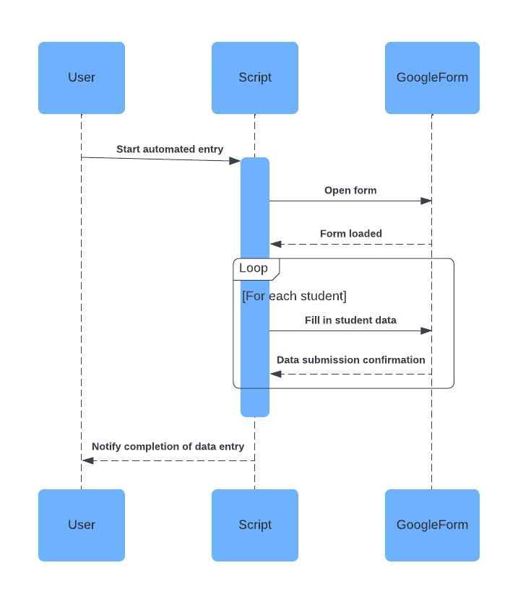

Fig 3.1.3 Sequence Diagram

## CHAPTER 4

## PROJECT DESCRIPTION

### 4.1 Methodology

The methodology for the Autorem: AutoLogin and ERP Reminder project is designed to ensure a seamless, reliable, and scalable automation solution for managing assignment deadlines. The project follows a structured approach, divided into clear phases, to ensure each component works efficiently and meets the system's functional and non-functional requirements. The methodology is as follows:

1. **Requirement Analysis & Setup**The first step involves identifying the key requirements for automating ERP login and assignment notification. This includes understanding the structure of the ERP system, identifying the fields to be extracted (such as assignment names and due dates), and ensuring that the necessary libraries and tools are in place, such as UiPath for automation. The setup involves configuring UiPath Studio and ensuring the RPA robot has access to the ERP system through appropriate login credentials and secure access methods.
2. **Data Source Setup**Next, a reliable data source is configured. For this project, assignment data is retrieved directly from the ERP system. The data source must be properly structured to ensure that it contains the correct information in the right format. It is essential to ensure that each field, such as assignment details, deadlines, and course information, aligns with the form fields that will be populated.
3. **Automation of ERP Login and Data Extraction**  
   Using UiPath, the project automates the login process to the ERP system. The robot interacts with the login interface by entering user credentials securely and retrieving the necessary data regarding upcoming assignments. This step involves using UiPath's web automation activities, such as Type Into and Click, to navigate through the ERP interface and extract relevant data.
4. **Error Handling**Since web scraping and automation can sometimes result in unexpected issues (e.g., changes in the ERP interface), error handling is incorporated. Try-Catch blocks are used to catch potential errors during data extraction, such as login failures or missing data. This ensures the system can recover gracefully from errors without compromising performance or accuracy.
5. **Sending Notifications**Once assignment data is extracted, the robot prepares email notifications for the user. This is done by mapping the extracted data to an email template, and using UiPath's Send SMTP Mail activity, the system sends real-time reminders to the students.
6. **Logging and Reporting**For effective tracking and troubleshooting, detailed logs of each automation session are maintained. UiPath’s Log Message activity is used to record the success or failure of each step, while a summary report is generated to document the entire process, including any errors encountered.
7. **Testing & Optimization**The automation process is thoroughly tested with different datasets to ensure that it works under various conditions, including different formats of assignment data. Optimization techniques, such as reducing unnecessary delays and ensuring stable element selectors, are applied to enhance performance and reliability.
8. **Deployment**  
   Finally, the system is deployed using UiPath Orchestrator to schedule the automation for periodic execution or trigger-based events, ensuring that reminders are sent out consistently. Once deployed, the system is ready for use by students, providing them with timely alerts for assignment deadlines.

## 4.1.1 Modules

The project Autorem: AutoLogin and ERP Reminder is divided into the following modules to ensure systematic automation and efficient management of assignment deadlines and notifications:

1. **Data Extraction**The goal of this module is to extract assignment data from the ERP system or any other data source used by the institution. The robot will use UiPath activities such as Get Text or Data Scraping to fetch the necessary assignment details, including due dates, course information, and assignment names. The data will be retrieved from sources like Excel, CSV, or the ERP database, depending on the structure of the institution’s data storage. If conditions will handle any missing or incomplete data, ensuring the accuracy of the extracted information.
2. **ERP Login Automation**This module focuses on automating the login process to the ERP system. The robot will use Type Into and Click activities to input the required credentials (e.g., username and password) and navigate through the ERP login page. Element Exists or Wait For Element activities ensure the page elements are loaded properly before proceeding. Error handling activities will also be implemented to manage login failures or other unexpected issues, ensuring the robot can recover gracefully if login attempts are unsuccessful.
3. **Assignment Data Entry and Notification Preparation**  
   Once the assignment data is extracted, this module automates the creation of notifications. The robot will organize and structure the extracted data into a predefined email template. Using Type Into and Send SMTP Mail Message, the robot sends automated reminders about upcoming assignment deadlines. It will ensure the format is correct and provide all necessary details, such as due dates and the associated course. This will help students stay on track without missing deadlines.
4. **Error Handling & Data Validation**  
   This module ensures the extracted assignment data is accurate and validates the inputs before generating reminders. If conditions will check for any invalid or incomplete assignment details (such as missing due dates or assignment names). Try-Catch blocks will be used to handle errors in case of issues like failed email deliveries or missing information. The system will log errors using Log Message or Write Line activities, and it will include a retry mechanism to ensure tasks are completed successfully.
5. **Notification Confirmation & Logging**  
   After sending the notifications, the robot will verify the successful delivery of emails. This module will check for confirmation messages from the email system (e.g., successful send notifications). If the notification is sent successfully, the system will log the success using Log Message, and update the status in a report. If any issues arise, the robot will log the failure and handle it according to predefined error-handling procedures, including retry attempts.
6. **Data Logging & Reporting**To ensure transparency and track the status of all reminders, this module handles logging the actions taken by the automation. The robot will maintain logs of every data entry attempt, including successful reminders and any errors encountered. Using Write Range, the system will update a central Excel or CSV file with the status of each notification attempt, including success or failure. Additionally, email notifications can be sent to stakeholders (such as administrators or users) to inform them of the process completion or any encountered issues.
7. **Post-Processing (Optional)**  
   This module is designed to allow the system to store or process the data beyond email notifications. For instance, the robot could update the ERP system or generate additional reports (e.g., CSV or Excel files) summarizing the status of the notifications. This ensures the data remains updated and easily accessible for future use or analysis.
8. **Scheduling & Deployment**The final module ensures that the automation runs as per the schedule or triggers based on assignment due dates. Using UiPath Orchestrator, the automation can be scheduled for periodic execution or triggered to run when new assignments are added to the ERP system. The robot will be deployed, monitored, and managed through Orchestrator, ensuring consistent execution and automatic recovery in case of failures or issues.

These modules work together to create an efficient, automated system that reduces the manual effort in managing assignments and ensures students receive timely reminders for due dates. Through this system, administrative workload is reduced, and the accuracy and timeliness of notifications are greatly improved.

## CHAPTER 5

## CONCLUSIONS

### 5.1 GENERAL

The Autorem: AutoLogin and ERP Reminder project addresses the critical challenge of automating assignment reminders by integrating ERP autologin functionality with timely email notifications. By leveraging UiPath’s robust automation capabilities, the project minimizes manual intervention, enhances operational efficiency, and ensures that students are consistently informed about upcoming assignment deadlines.

Key findings from the development and implementation of the project include:

1. **Automation Benefits:**  
   The automation simplifies the process of logging into the ERP system, extracting assignment-related data, and generating timely email reminders. By eliminating manual steps, the system ensures a reduction in human error, enhances accuracy, and significantly reduces the time required for task execution.
2. **Scalability:**  
   The project is designed to adapt to diverse ERP systems and data volumes. Whether dealing with small-scale or large-scale datasets, the automation remains efficient. With UiPath Orchestrator, the system can be scaled seamlessly to manage an increasing number of users or assignments, catering to evolving institutional needs.
3. **Flexibility and Customization:**  
   The system allows for easy configuration to adapt to various ERP platforms and email templates. Changes in assignment structures or notification requirements can be implemented with minimal adjustments, ensuring the solution’s longevity and relevance to dynamic administrative processes.
4. **Error Handling and Monitoring:**  
   Comprehensive error-handling mechanisms ensure reliability by identifying and managing issues such as failed logins, incorrect data extraction, or unsuccessful email deliveries. Logs and reports generated by the system provide transparency, aiding in quick troubleshooting and continuous improvement.
5. **Integration with UiPath Orchestrator:**  
   Deploying the system to UiPath Orchestrator enables seamless scheduling, autonomous execution, and real-time monitoring. Orchestrator’s dashboard provides an overview of the system’s performance, ensuring timely resolution of issues and facilitating process optimization.
6. **Enhanced Workflow Management:**  
   The project streamlines the process of tracking assignment deadlines, reducing the administrative burden on staff. By ensuring that students receive timely notifications, the system fosters better academic organization, improves deadline compliance, and supports overall institutional efficiency.

In conclusion, the Autorem: AutoLogin and ERP Reminder project demonstrates the power of RPA in automating critical academic workflows. By addressing the repetitive and time-sensitive task of assignment management, the solution enhances productivity, ensures timely communication, and minimizes errors. Future enhancements could focus on integrating advanced analytics for tracking student compliance, expanding the system to support other ERP features, and incorporating mobile notifications for broader accessibility. The project establishes a strong foundation for leveraging automation to improve educational administration.

## REFERENCES

1. UiPath Official Documentation. (n.d.). Robotic Process Automation (RPA) Overview.

Retrieved from <https://www.uipath.com/>

1. Jain, S., & Bhutani, S. (2020). Robotic Process Automation (RPA): A Literature Review and Implementation in Business Processes. International Journal of Advanced Research in

Computer Science and Software Engineering, 10(7), 42-47.

1. Huang, K. T., & Lee, R. W. (2021). Automation of Contract Management Systems Using Robotic Process Automation (RPA). Journal of Business & Technology, 23(3), 134-140.

<https://doi.org/10.5555/jbt.2021.23.3.134>

1. Brown, G. (2020). The Future of Automation in Business Processes: A Focus on RPA Tools.

Springer International Publishing.

1. Bhatnagar, A. (2021). Optimizing Business Workflows with UiPath RPA: A

Comprehensive Guide. Wiley Publishing

1. Zhu, Y., & Ouyang, L. (2019). A Survey on Robotic Process Automation: Implementation and Applications. International Journal of Computer Applications, 182(5), 1-6.

<https://doi.org/10.5120/ijca201991847>

1. UiPath Academy. (n.d.). UiPath Orchestrator and Cloud Automation: A Deep Dive.

Retrieved from <https://academy.uipath.com/>

1. Harman, R., & Hamilton, L. (2022). Best Practices for Implementing RPA in the Enterprise.

Automation Review Journal, 14(2), 45-52.

1. Ferrer, J., & Sancho, D. (2020). The Role of RPA in Contract Management Automation: A Case Study of the Legal Sector. Journal of Legal Tech and Automation, 9(1), 20-26.

<https://doi.org/10.2139/ssrn.3524437>

1. Gartner. (2022). Magic Quadrant for Robotic Process Automation. Retrieved from https://www.gartner.com/en/documents/3987467

These references provide foundational knowledge on RPA, particularly focusing on automation tools like UiPath, contract management automation, and RPA's impact on business processes.

**SCREENSHOTS**

1. Workflow Screenshot

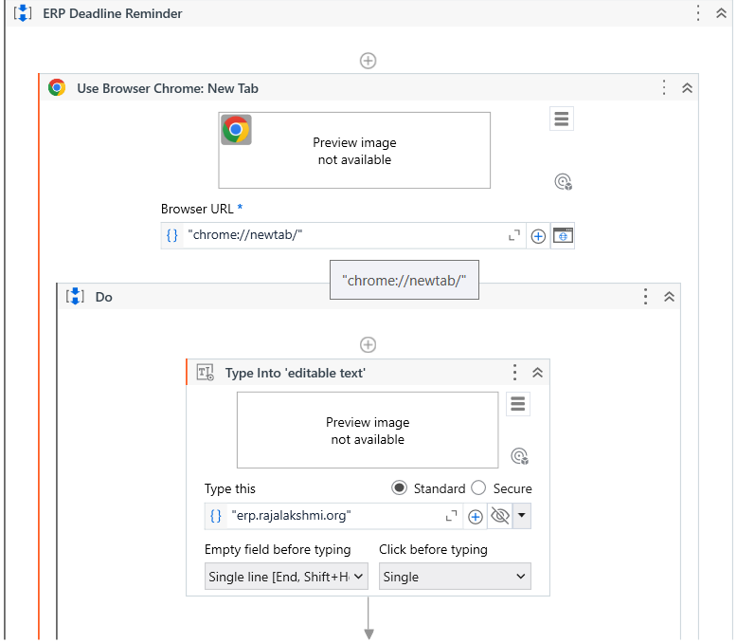

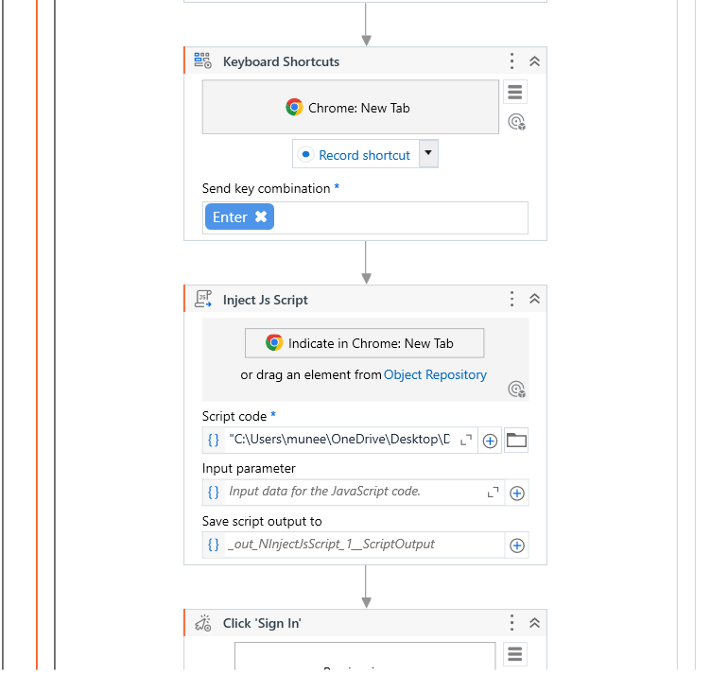

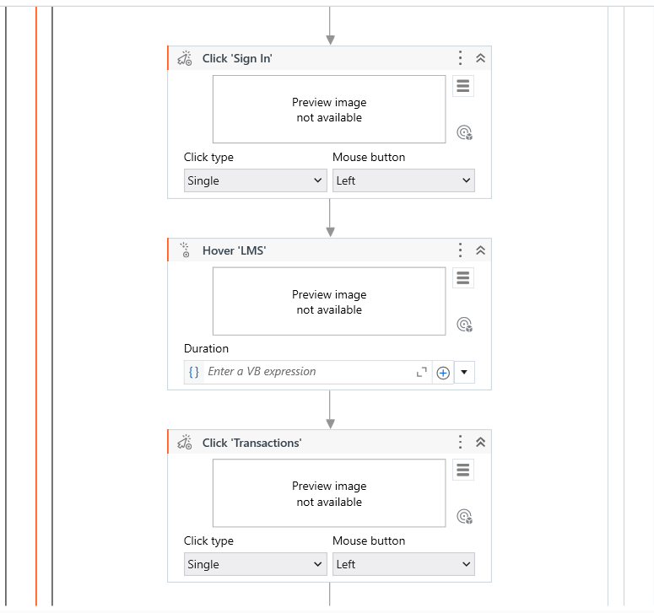

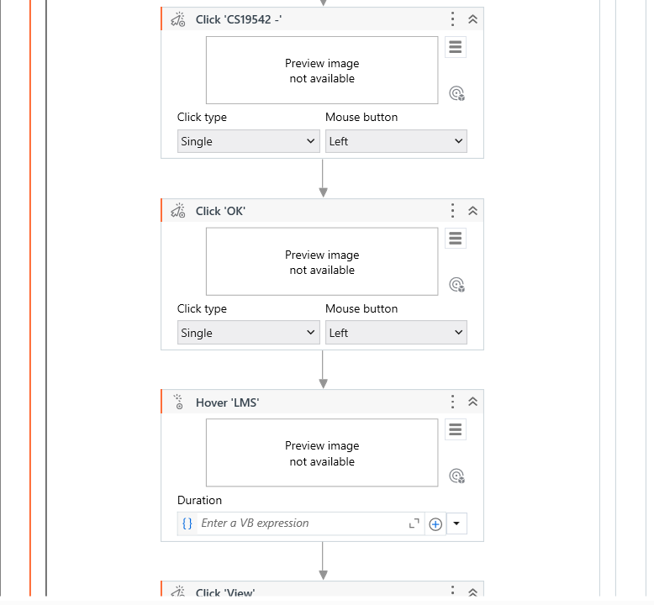

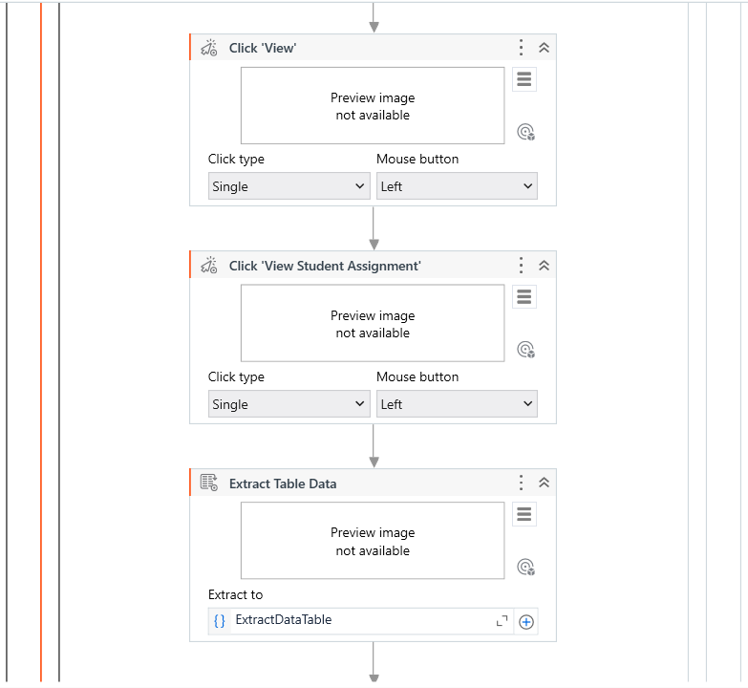

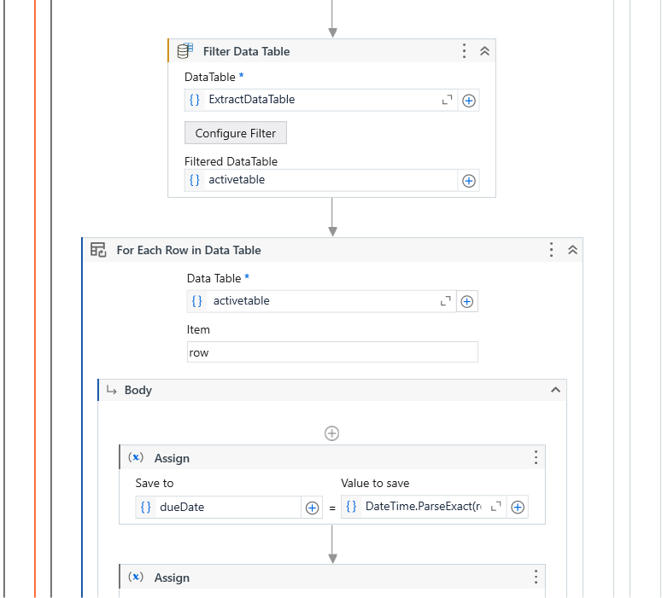

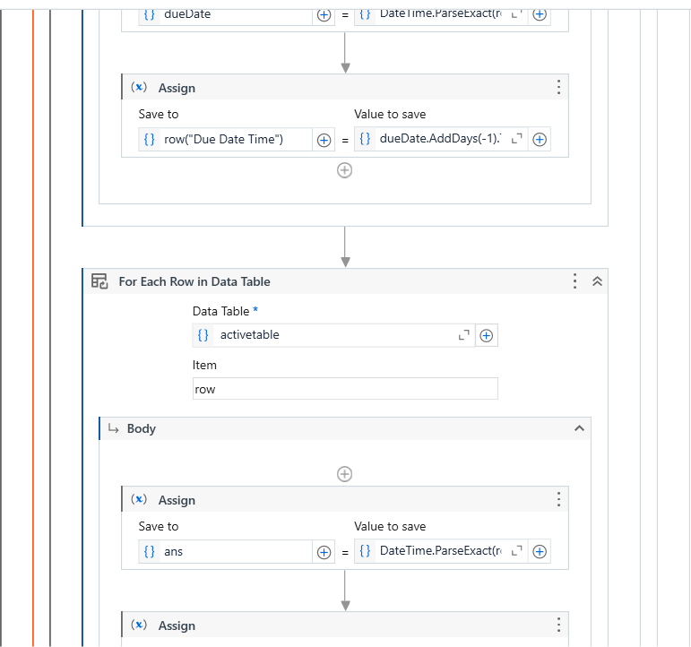

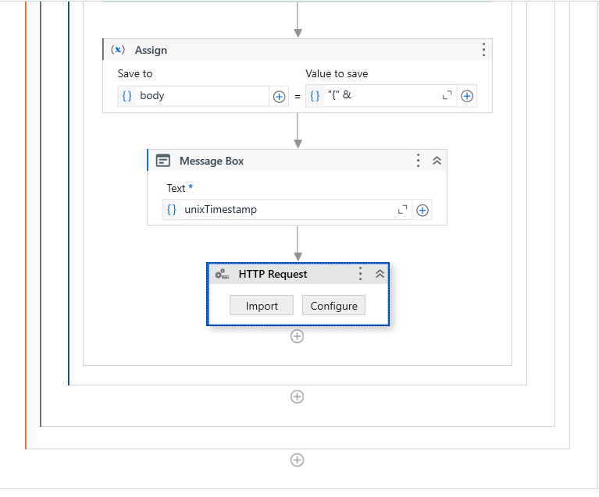

**APPENDICES**

**Appendix 1: Key Activities in Autorem Workflow**

1. **Browser Interaction**Open Browser: Opens the ERP system in a web browser for data scraping and navigation.  
   Click: Automates clicks on various ERP elements such as "Sign In," "Transactions," "CS19542," and "View Assignments."  
   Type Into: Enters login credentials or filters directly into the ERP system fields.
2. **Data Extraction**  
   Extract Data: Retrieves assignment deadlines from the ERP using data scraping and stores the data in a structured table for further processing.
3. **Data Handling**  
   For Each Row in DataTable: Iterates through each extracted assignment record to analyze and process deadlines.  
   Assign: Assigns extracted data fields like assignment name and due date to variables for notifications.
4. **Error Handling**  
   If: Validates data integrity, ensuring deadlines are not missed or invalid.
5. **Notification System**Send Mail: Automatically sends email alerts to students about approaching deadlines using extracted data.
6. **Logging**  
   Write Line or Log Message: Logs process activities for tracking success or diagnosing errors.

**Appendix 2: UiPath Activities Used**

1. **Open Browser**

Purpose: Automates the process of opening the ERP system in a web browser.

Input: URL of the ERP system login page.

Output: Browser session for subsequent activities.

2. **Type Into**

Purpose: Used for entering login credentials (username and password) into the ERP

Input: ERP login form fields.

Output: Successful authentication and redirection to the dashboard.

3. **Click**

Purpose: Interacts with various buttons or tabs in the ERP system.

Input: Selectors for the required buttons or menu items.

Output: ERP interface navigated to the desired section.

4. **Data Scraping**

Purpose: Extracts data related to assignment deadline from the ERP interface.

Input: Assignment table structure on the ERP dashboard.

Output: DataTable containing assignment details such as name and due date.

5. **For Each Row**

Purpose: Loops through the extracted DataTable to process each assignment entry.

Input: DataTable with assignment data.

Output: Individual assignment details processed.

**6. Send Mail**

Purpose: Automates the sending of email reminders for upcoming assignments.

Input: Assignment details formatted into an email template and recipient addresses.

Output: Email notifications sent to users.

**7. Log Message**

Purpose: Tracks the status of each operation, including success or error messages.

Input: Message indicating the outputs of actions like login, scraping, or email dispatch.

Output: Logs displayed in the output panel for monitoring and debugging.

**8. Try Catch**

Purpose: Manages errors that occur during the workflow execution.

Input: Exceptions such as failed data scraping or email errors.

Output: Process recovery or error notification in logs.

**Appendix 3: Screenshots of Workflow**

**Workflow Overview:** Displays the sequence of activities, including browser interaction, data scraping, and notifications.

**Data Scraping Configuration:** Shows the setup for extracting assignment deadlines from the ERP.

**Notification Email:** Example configuration of the "Send Mail" activity used to dispatch alerts.